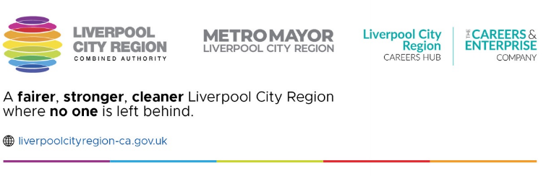

Careers Education: Supporting our SEND students

Tuesday 2nd July

9:30am-2:30pm

Liverpool Hope University

Eden Building, Arbour Room

Over the last 12 months Liverpool City Region Careers Hub has been working in partnership with Liverpool Hope University to explore the barriers encountered by young disabled people accessing careers provision in mainstream school. This will be an engaging and interactive event to share our work and to gather feedback from professionals working with young disabled people. You will have the opportunity to

* hear directly from young people
* hear from a range of organisations and specialists who support disabled young people with their transitions
* give feedback on resources that have been developed as part of the project
* share best practice when developing career provision for SEND students.

We do hope you will be able to join us. To book your place please [click here.](https://store.hope.ac.uk/product-catalogue/school-of-education/events/careers-education-supporting-our-send-students)

If you have any questions or would like to know more, please contact Claire Caddick [claire.caddick@liverpoolcityregion-ca.gov.uk](mailto:claire.caddick@liverpoolcityregion-ca.gov.uk) or Marie Caslin [Marie.caslin@edgehill.ac.uk](mailto:Marie.caslin@edgehill.ac.uk)