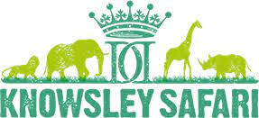

Careers in the Curriculum
Maths Level 1 using calculations:
Multiplication and division of whole numbers

Worksheet 2: Meerkats

Question 1: Name the different animals that are in the same section as the Meerkats.

Question 2: How many Meerkats are in the section?

Question 3: Meerkats eat their entire bodyweight in food per day. The Meerkats at Knowsley safari park weigh 2lbs each. The keepers have bags of insects that they use to feed the Meerkats. The bags weight 3lbs each.

- How many bags do you need to feed one Meerkat for the full week?

Is there any food left over?

- How many bags do you need to feed all the Meerkats for a full week?
Is there any food left over?

